**Format for uploading details in Github and Slack in word file format**

**(Fill this format(docx) daily and upload it in both Github and Slack)**

**Student Name : SURYA PRAKASH S**

**Class and Sec : VI B**

**USN : 4AL17CS101**

|  |  |  |  |  |
| --- | --- | --- | --- | --- |
| **Online Test Details** | | | | |
| **Subject** | **-** | | | |
| **Semester** | **VI -B** | | **Duration** | **-** |
| **% of marks** | | **-** | | |

**Encl : snapshot of the test result**

|  |  |  |  |
| --- | --- | --- | --- |
| **Certification Course Details** | | | |
| **Course** | **Webinar on Carrer opportunities and Industry readiness during difficult times**  **Webinar on AI** | | |
| **Certificate Provider** | **IIT** | **Duration** | **04 hours** |

**Encl : snapshots of the daily class acitivities (atleast two snap shots)**

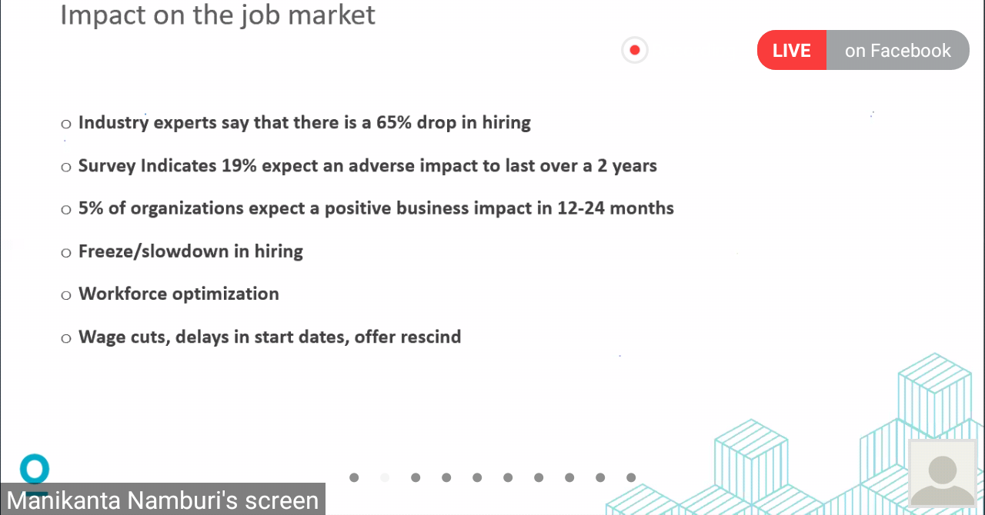

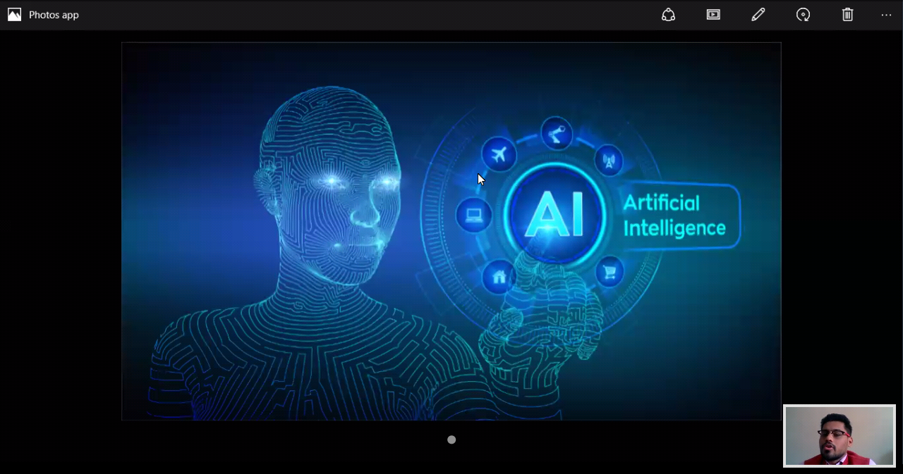

|  |  |
| --- | --- |
| **Coding Challenges** | |
| | **Problem Statement : 1. Python Program to Create a Class in which One Method Accepts a String from the User and Another Prints its 2. Write a program that will read a sequence of positive real numbers entered by the user and will print the same numbers in sorted order from smallest to largest. The user will input a zero to mark the end of the input. Assume that at most 100 positive numbers will be entered** | | --- | | |
| **Status: Completed** | |
| **Uploaded the report both in Github & Slack** | **Yes** |

**Encl : snapshots of your response to challenge.**

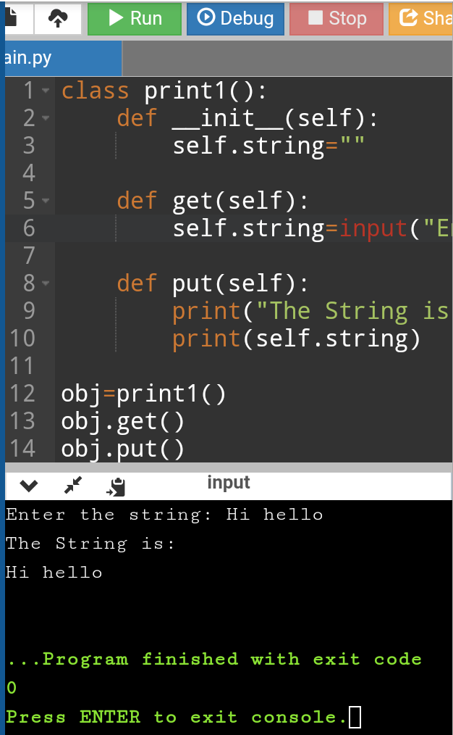

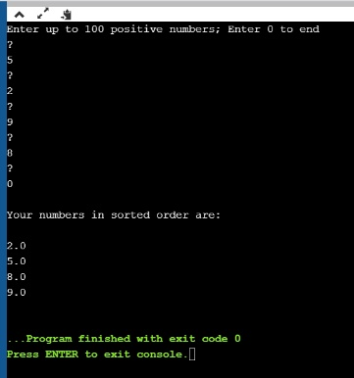

https://github.com/SPSSURYA/Online-Coding-And-Certification-Course